# Week 6 Discussion Board

I want to find out more about Tableau. Tableau is an effective application for data visualisation and analysis that offers a straightforward, interactive user interface.

Tableau's adaptability is one of its advantages. It offers a wide range of visualisation choices, including bar charts, line graphs, scatter plots, and maps, and it can link to a variety of data sources, including spreadsheets, databases, and cloud storage. The application also enables users to build interactive dashboards that allow for deeper data exploration.

Tableau offers tools including tutorials, forums, and a library of pre-built visuals that users can download and use, as well as a large community. It also provides a comprehensive collection of developer tools and APIs for building unique visualisations and interacting with other programmes (Batt, Grealis, Harmon, & Tomolonis, 2020).

An illustration of a Tableau visualisation is seen in the screenshot below. It is a map that displays the total number of COVID-19 cases reported in each US state. I appreciate this specific representation since it depicts the virus's geographic distribution, which might be useful in understanding how it spreads and what effects it has. Utilizing colour effectively helps to visualise the data, and the dashboard's interactivity makes it simple to explore the data.

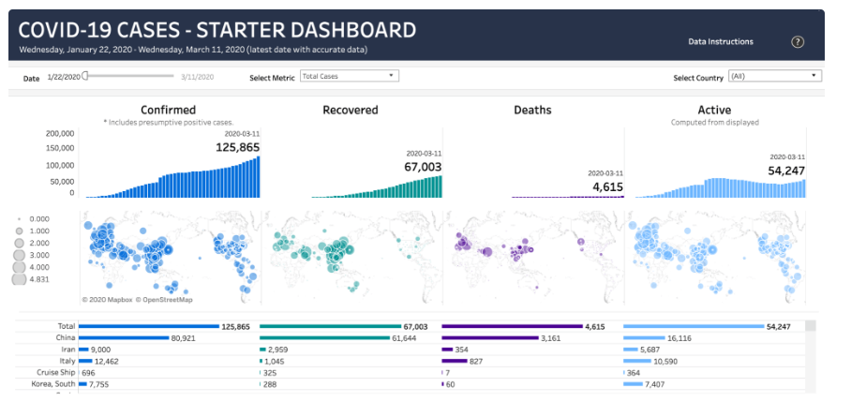

Source: (Steve, March 9, 2020)

A platform for data analysis and visualisation, Tableau is a very flexible and user-friendly data visualisation application. Organizations in a variety of sectors, including banking, healthcare, retail, and education, have utilised it to generate potent visualisations that aid in communicating insights and guiding data-driven decisions.

For data scientists and business analysts who need to analyse and visualise data, Tableau is a useful tool. It's a fantastic option for data visualisation because of its user-friendly design, adaptability, and strong community.

# References

Batt, S., Grealis, T., Harmon, O., & Tomolonis, P. (2020). Learning Tableau: A data visualization tool. *The Journal of Economic Education*, *51*(3-4), 317-328.

Steve Schwartz., (March 9, 2020)., Building a COVID-19 resource hub: Tracking the virus through actionable data. Available at: <https://www.tableau.com/blog/covid-19-data-resources-to-understand-virus-impact>

# Reply 1

The information you provided can be easily comprehended even by non-technical users, and your message is as concise as ever. Reading your posts is always fun. I want to emphasize the important elements you mentioned earlier. Every organization's ability to succeed is based on how well its internal operations are carried out. Users can connect to different data sources, analyse data, and create interactive dashboards and visualisations using Tableau, a business intelligence and data visualisation application. It offers a drag-and-drop interface for exploring data and the capability to produce incredibly beautiful and educational reports. Businesses, data scientists, and analysts all frequently utilise it to glean insights from massive amounts of data and make data-driven decisions.

# Reply 2

Happy day! It is admirable how carefully you covered each and every subject. Because you continuously provide clear, in-depth knowledge about each subject, making it understandable even for individuals without prior knowledge of the area, I love reading your writings. Organizations use Tableau to analyse data, get insights, and make defensible decisions. Large volumes of data may be swiftly and readily analysed with this method, and interactive visualisations that can be shared with stakeholders are also produced. Finding patterns, trends, and outliers in your data is simple using Tableau, and this information can be used to help you make wise business decisions.